**Bulk Task creation through Google Maps**

This document summarizes the setup of creating a bulk task for customers through a suitelet. A single task will create for several customers. The customers will be selected by plotting the location on the maps. The user could plot a particular location on the map and a task will be created for each of the customers in that particular location.

The navigation for this section is List > Custom > Create task for Customers

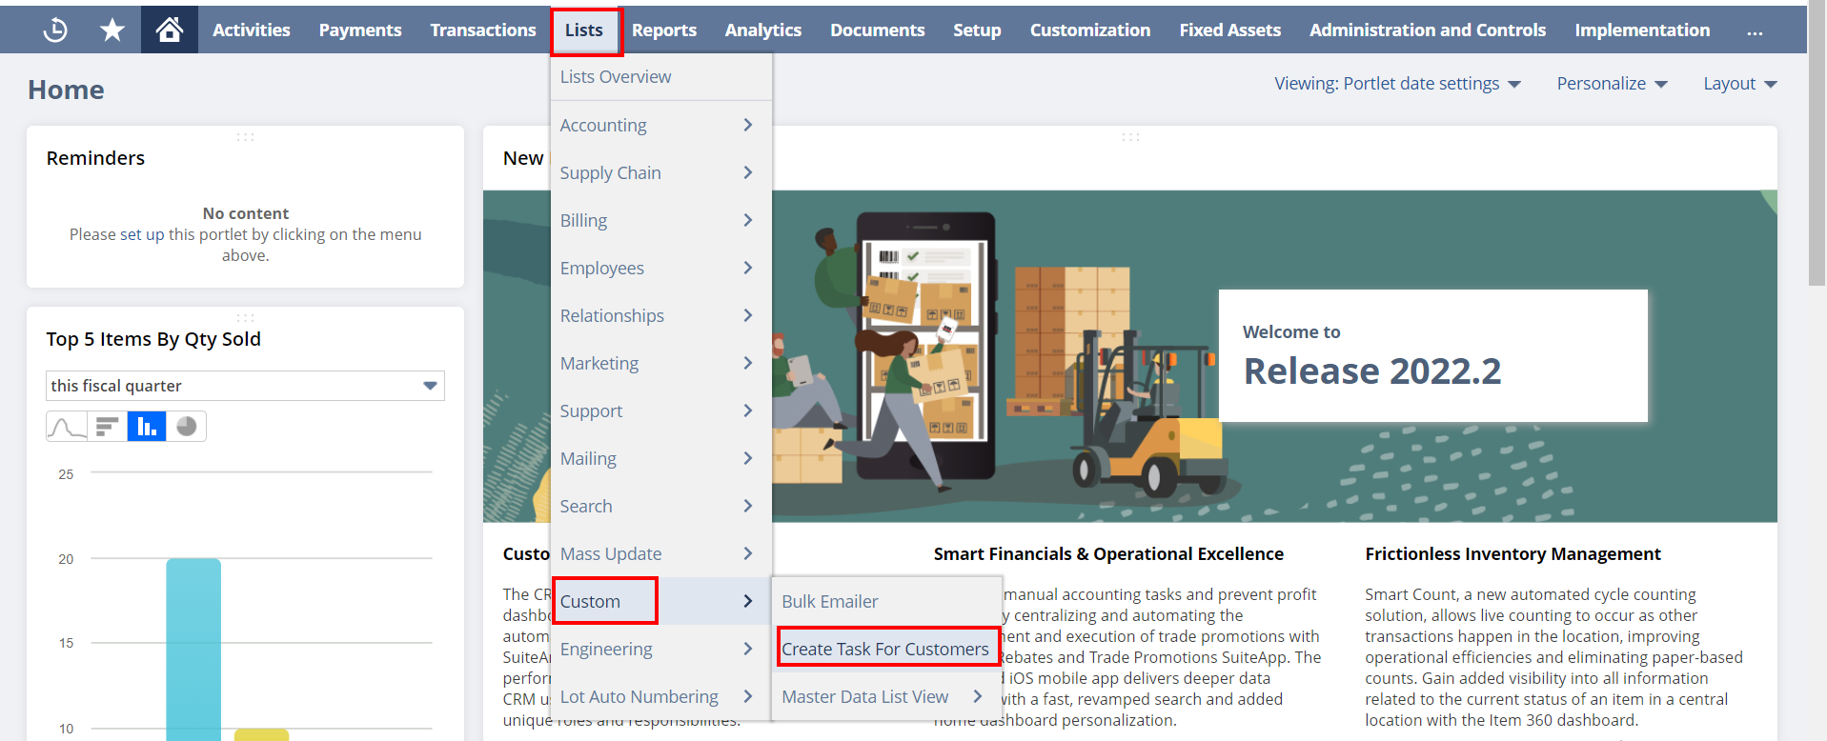

The first page consists of 5 types of filters, which are Sales rep partner, Customer category, Training Grading, HOG Brick, and Saved search. The user should select at least one filter.

The first filter is **Sales rep partners**. The user could select a sales rep partner and when the user clicks the Next button, the map will list all the customers under the selected Sales rep partner.

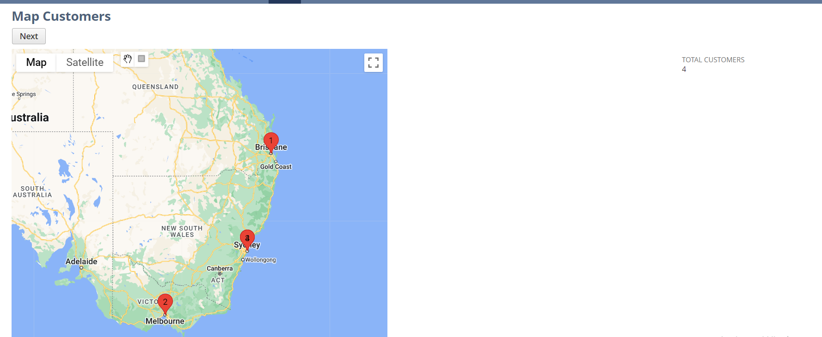

User could zoom out and zoom in on the map to view the whole section. Each customer will be marked using a red marker.

The second filter is **Customer Category**, which is a field on the customer record.

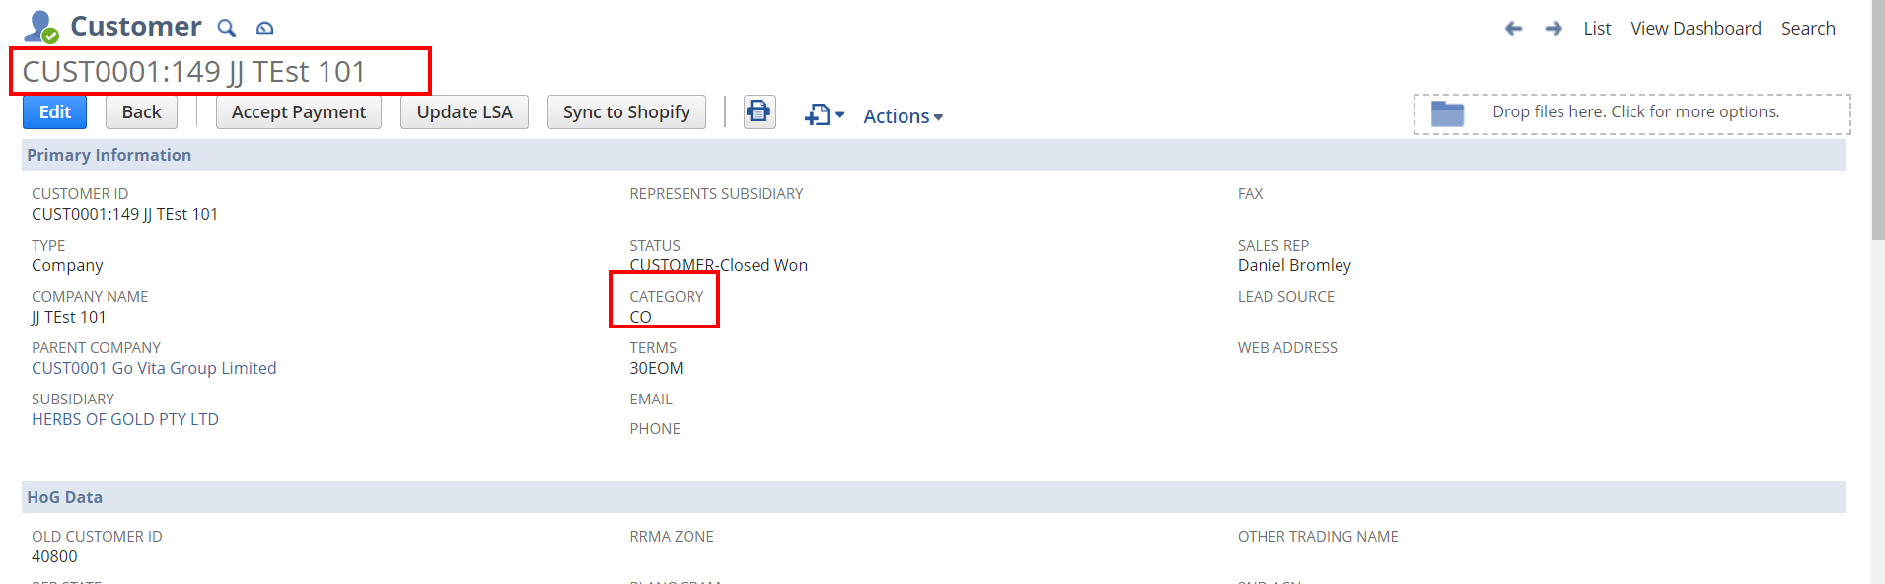

Third filter is **Training Grading** and the fourth one is **HOG Brick** where both of these values are from Customer record. Both of these values are populating on the customer record from another child record **Planograms**.

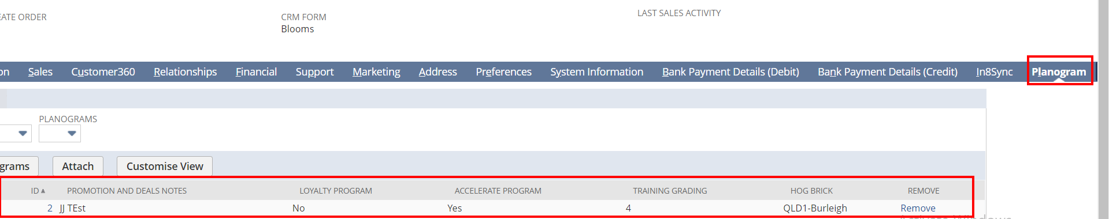

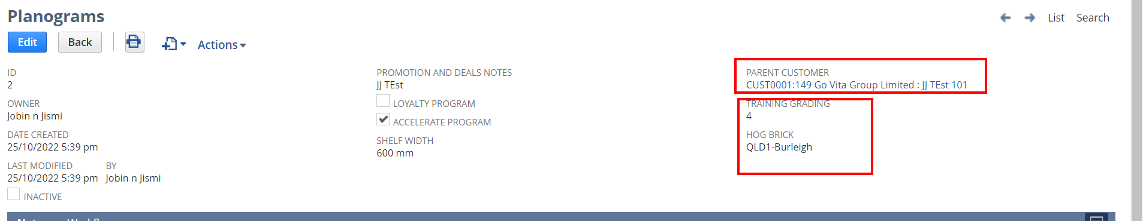

The last filter is **saved search,** which lists Customer searches. To list these customer searches, there is another [saved search](https://6687177.app.netsuite.com/app/common/search/searchresults.nl?searchid=1373&whence=) is used, where the user could specify the internal ID of the searches, they want to list on the Saved search filter.

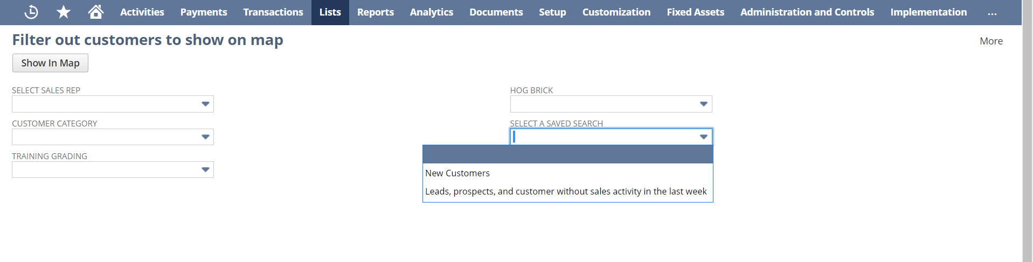

On the next page, user could plot the customers on the map using the square label on the map.

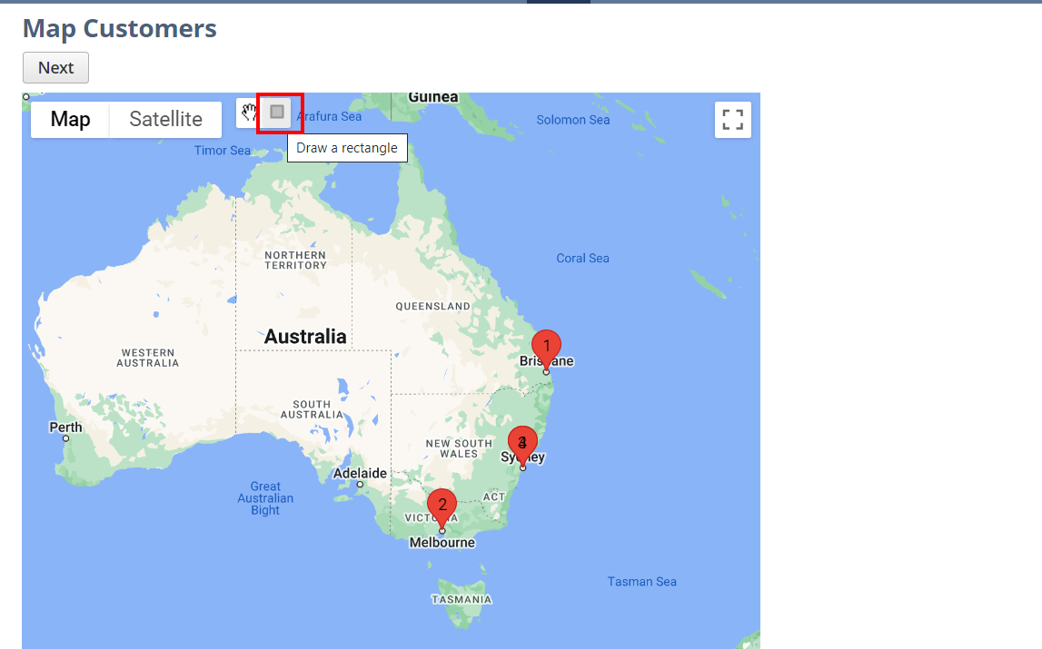

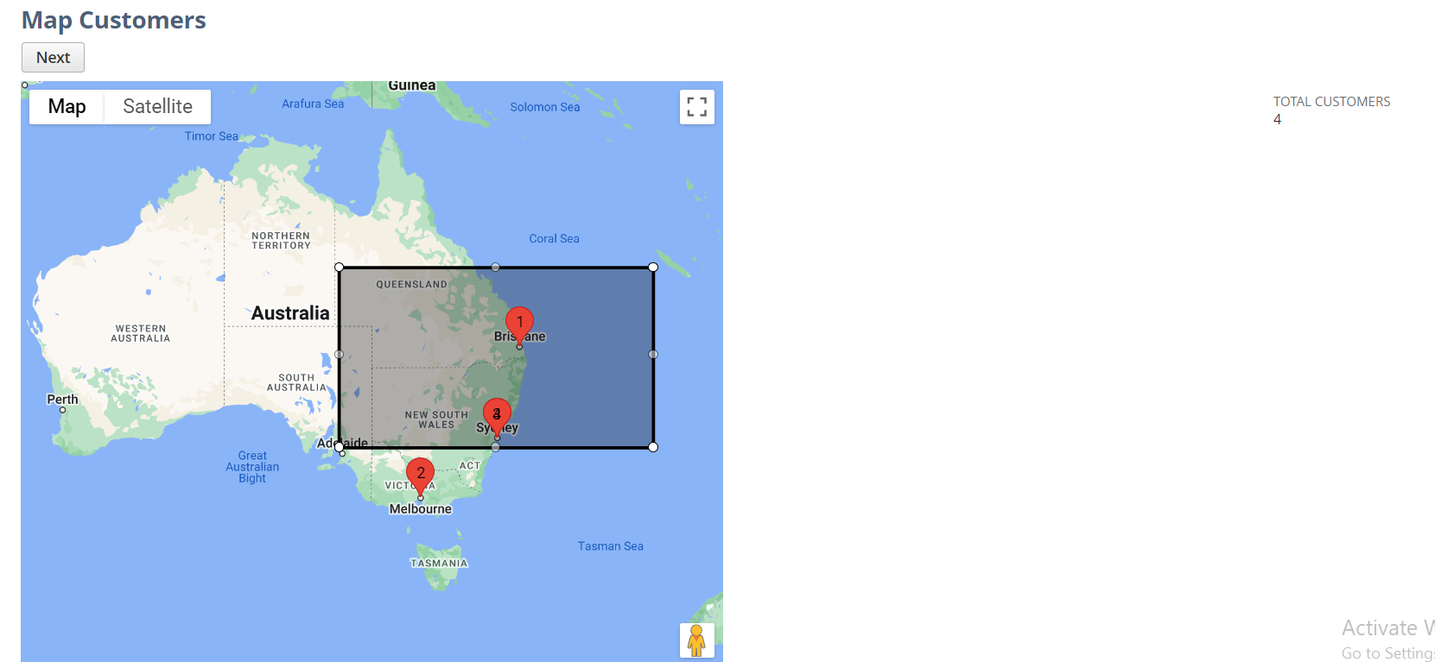

After plotting the customers, click on the Next button. It will lead to the 3rd page, where the plotted customer details will be listed.

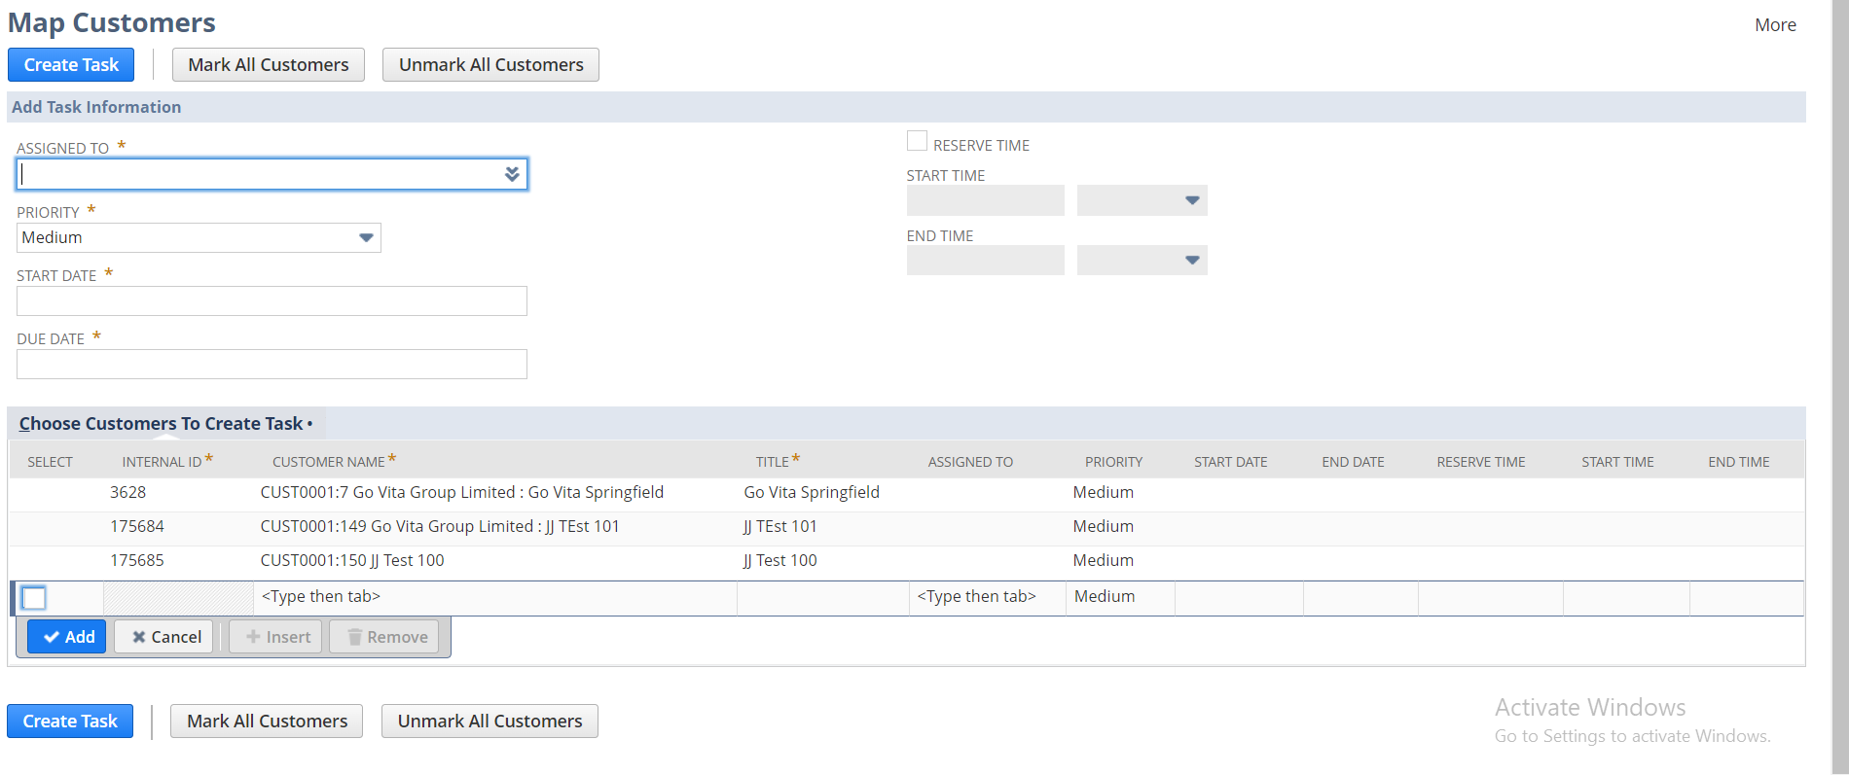

This is the page where the task creation initializes. There are some mandatory fields are available here.

All tasks should have an assignee. This can be selected on the **Assigned To** field. The same field is also available on the sub list, where there the user could change the assignee for a particular task. All the fields on the Body level are a common field. Ie; the value on the body-level fields will be common for all the tasks. To change the values for any particular task, the user could do on the line- level.

The priority of the task can be selected on **Priority** field. User could provide a Start and Due date for the task. There is a check box available on the page **Reserve Time,** where this checkbox is checked, the user could enter Start time and End time for the task. The dropdown on the Start and End time fields consist of the time entries. Selected values will be automatically populated on the Text field near the drop down. The user could also edit the time on the Text field with the correct format.

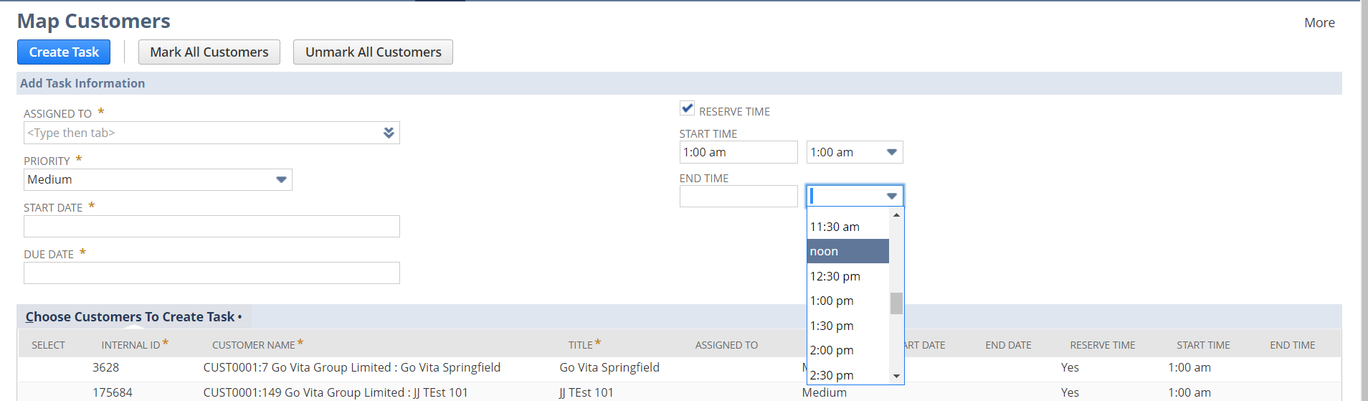

The user could add more customers on the list by selecting the customers on the sub list. When the customer is selected the Internal ID value will be auto populated.

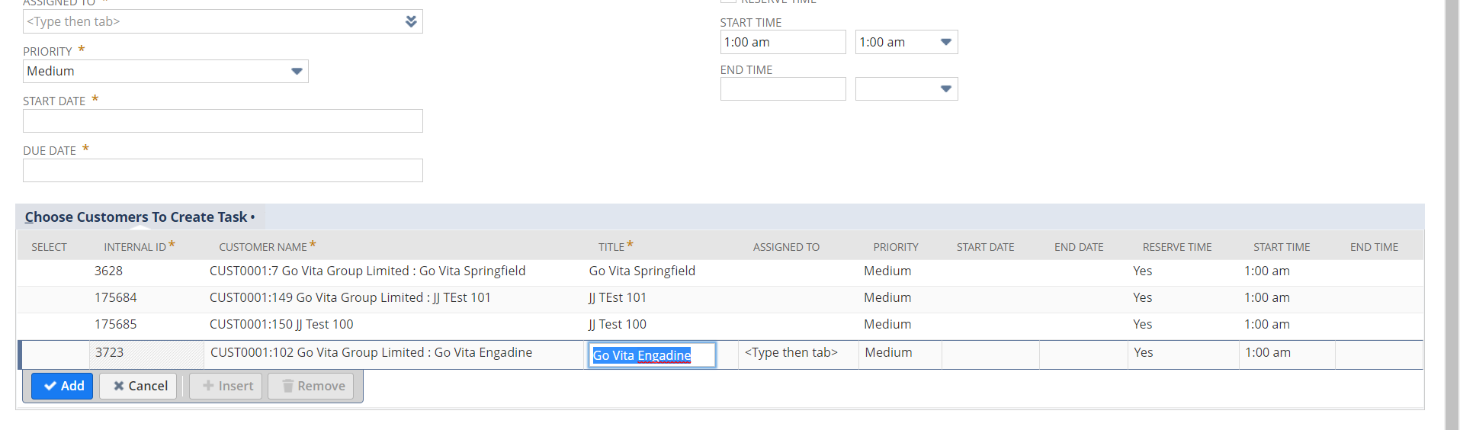

Tasks will be created for the lines, which are checked the SELECT checkbox. If there are any open tasks are available with the same assignee and customer, an alert will be populated and when the OK button clicks, the duplicate lines will be removed and tasks will be created for the remaining lines.

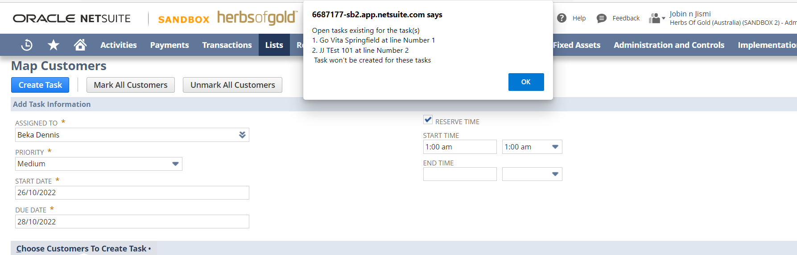

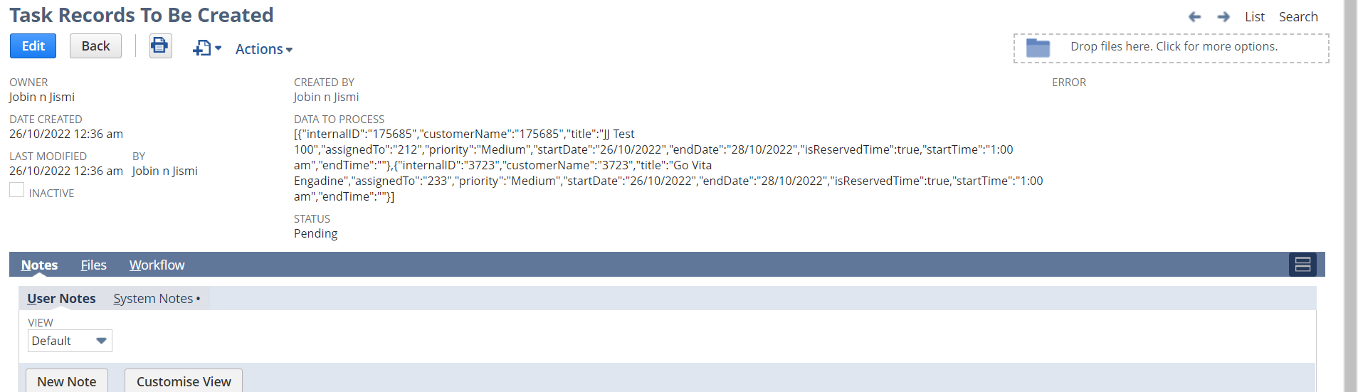

When this page is submitted, all the details will be stored in a custom record [Task Records To Be Created](https://6687177.app.netsuite.com/app/common/custom/custrecord.nl?id=1491&e=T) a Map/Reduce script will be executed in the background. Original Task records will be created from that Map/Reduce script.

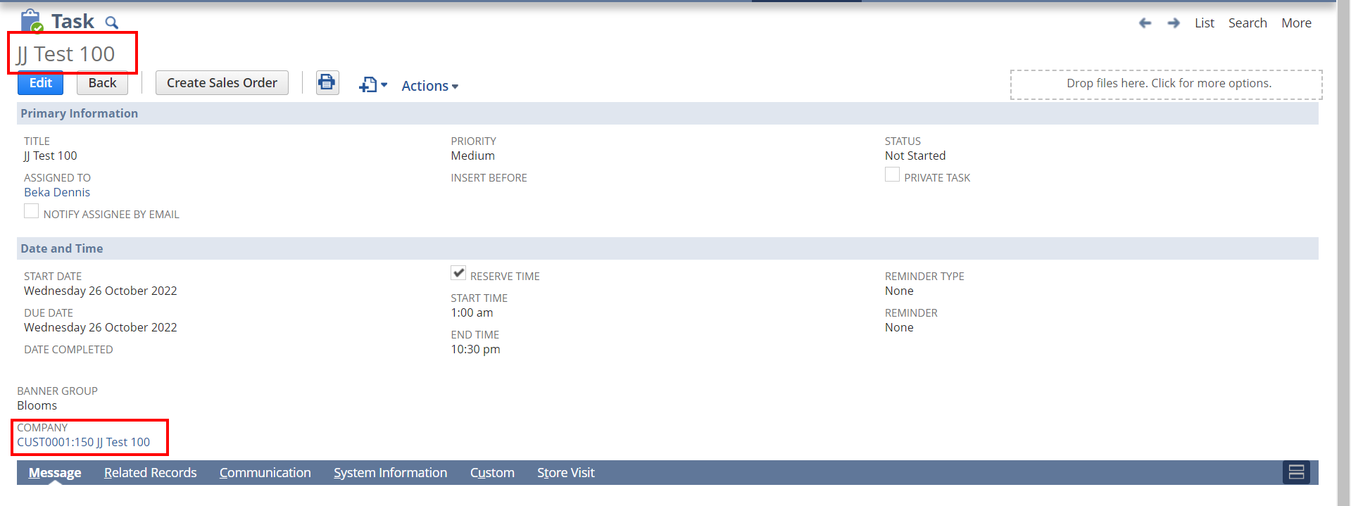

**Related Scripts:**

[JJ SL Filterout Customers HGPL-10](https://6687177.app.netsuite.com/app/common/scripting/script.nl?id=1046)

[JJ SL Create Task HGPL-13](https://6687177.app.netsuite.com/app/common/scripting/script.nl?id=1047)

[JJ MR Create Task HGPL-13](https://6687177.app.netsuite.com/app/common/scripting/script.nl?id=1048)

[JJ CS Backend Client script HGPL-10](https://6687177.app.netsuite.com/app/common/media/mediaitem.nl?id=68791&e=T)